Nigeria's TB Burden Compared with Other High-Burden Countries
Analysis report prepared by Eseonu Rejoice Adaeze, October 2026
- Executive Summary
This project analyzes Nigeria’s tuberculosis (TB) burden in comparison with 29 other selected high-burden countries using data from the World Health Organization’s Global Tuberculosis Report 2025, with estimates through 2024.
The analysis explores estimated TB cases, incidence, deaths, case detection, treatment outcomes, and drug resistance. Excel Power Query was used for data preparation, MySQL for data analysis, and Power BI for visualization. The selection of 30 high-burden countries was based on applying WHO method to 2024 data, i.e. the 20 countries with the most estimated new cases, plus the 10 countries with the highest incidence rate that are not already in the top 20 and have at least 10,000 cases. It does not imply that the list is the WHO’s official high-burden country list.
Key findings indicate that Nigeria ranked 6th among the 30 selected counties by estimated new TB cases, with approximately 510,000 cases in 2024. Its estimated case detection rate increased from 21% in 2015 to 79% in 2024, although approximately 21% remained undetected (107,000 cases). Treatment success for new and relapse TB cases was 94% for the 2023 cohort, compared with 76.3% for the 2022 MDR-TB cohort.
The findings highlight the importance of continued attention to case detection and access to treatment for drug-resistant TB. However, the analysis relies on modelled estimates, and its findings describe patterns rather than establish causal relationships.
- Objective
This analysis shows where Nigeria stands on tuberculosis (TB) compared with other high-burden countries. It looks at whether Nigeria is finding patients (case detection), curing them (treatment outcomes), and reaching those with drug-resistant TB. The goal is to find where the biggest gap is.
Why this project: My final-year pharmacy project studied Isoniazid and Rifampicin, two first-line TB drugs used in tuberculosis therapy, through pharmaceutical chemistry. This project extends my interest in tuberculosis from the pharmaceutical perspective to public health, examining disease burden, case detection, treatment outcomes and drug resistance at the population level.

- Questions answered
- How big is the problem? Nigeria's TB cases, incidence rate and deaths compared with other high-burden countries, and the trend over time.
- Are we finding the patients? The case detection rate (cases found compared with estimated cases).
- Are we curing them? Treatment success for new TB cases and for MDR-TB.
- How serious is drug resistance? The share of new cases that are rifampicin-resistant, and how many resistant cases are estimated and reached.

- Data Source
WHO Global Tuberculosis Programme data (WHO Global TB Report 2025, with estimates up to 2024), downloaded on 16 October 2026 from https://www.who.int/teams/global-tuberculosis-programme/data:
File | Used for
TB_burden_countries_2026-10-16.csv | Cases, deaths, case detection (Questions 1 and 2)
TB_outcomes_2026-10-16.csv | Treatment success (Question 3)
MDR_RR_TB_burden_estimates_2026-10-16.csv | Drug resistance (Question 4)
TB_data_dictionary_2026-10-16.csv | Column definitions
The three data files share a country code (iso3) and year, which were used to join them.

- Tools Used
- Excel Power Query for Cleaning and renaming columns.
- MySQL for Analysis
- PowerBI for Visualization

- Data preparation
Full details are in the separate Data Cleaning Documentation. In summary:
S/N | Table | Rows loaded | Blanks found, converted to NULL
1 | tb_burden_estimates | 5,322 | 339 in case_detection_pct
2 | mdr_rr_burden_estimates | 2,150 | 330 rows blank in all 3 estimate columns
3 | treatment_outcomes | 6,399 | New_cohort 4,058; new_success 4,070; new_succ_rate_pct 1,102; mdr_cohort 3,355; mdr_success 3,438

Method:
MySQL’s import wizard drops rows that have a blank in a numeric column. To keep every row, columns with blanks were first imported as TEXT, blanks were converted to NULL, then the columns were changed to their numeric types (INT, BIGINT or DOUBLE).
Validation checks:
- Row counts for each table matches the source files – 5,322 rows for tb_burden_estimates, 2,150 rows for mdr_rr_burden_estimates and 6,399 rows for treatment_outcomes.
- Nigeria returns 25 rows for tb_burden_estimates (2000 to 2024).

- Methodology
- High-burden countries (30): WHO's method was applied to 2024 estimates: the 20 countries with the most estimated new cases, plus the 10 countries with the highest incidence rate that are not already in the top 20 and have at least 10,000 cases. WHO's official list uses 2019 data, so this list is similar but not identical.
- Top 7 countries: For the detailed comparison, Nigeria is compared with the six other countries with the most TB cases: India, Indonesia, China, the Philippines, Pakistan and DR Congo.
- Years used. Each indicator uses the latest year available:
Indicator | Year
Cases, incidence, deaths, case detection, resistance estimates | 2024
Treatment success, new and relapse cases | 2023
MDR-TB treatment success and share of resistant cases reached | 2022
N.B: MDR outcomes lag by about two years, so 2023 is blank.
Definitions:
- Case detection is the percentage of estimated cases that were found and reported.
- Treatment success is the share of a treatment cohort that was cured or completed treatment.
- Share of resistant cases reached is MDR-TB patients who started treatment divided by estimated rifampicin-resistant cases. It is an approximate measure, because MDR-TB (resistant to rifampicin and isoniazid) and RR-TB (resistant to rifampicin) are close but not identical groups.
- Rates were ranked using unrounded values calculated from the raw counts, because WHO's rounded percentages create ties.

- Analysis and findings
8.1. How big is the problem?
- Nigeria ranks 6th of the 30 high-burden countries for estimated new cases (510,000 in 2024). India (2.71 million) and Indonesia (1.08 million) have the most cases.
- Its incidence rate is 219 per 100,000, which ranks only 20th of 30. Nigeria has many patients mainly because its population is large. Papua New Guinea (664) and the Philippines (625) have the highest rates.
- The estimated TB death rate is 26 per 100,000.
- Top 10 high burden countries are: India, Indonesia, Philippines, China, Pakistan, Nigeria, Democratic Republic of Congo, Bangladesh, Myanmar, and South Africa.

8.2. Are we finding the patients?
- Nigeria ranks 9th of 30 for estimated cases detected in 2024 (79%), and 2nd of the Top-7 countries (India is highest at 92%; Mongolia is lowest at 18%).
- About 21% of estimated cases, roughly 107,000 people, were not detected.

  - Are we curing them?
- For new and relapse cases in 2023, 94% were successfully treated, ranking Nigeria 10th of 30 and 4th of the top 7 (DR Congo 95.2%, Pakistan 94.9%, China 94.5%). Ethiopia is highest at 96.1% and Angola lowest at 63%.
- For MDR-TB cases in 2022, Nigeria achieved 76.3% success rate, ranking it 13th of the 28 countries with data. DR Congo is highest (96.1%) and Papua New Guinea lowest (32.7%). Angola and Central African Republic had no MDR-TB data.

  - How serious is drug resistance?
- In 2024, Nigeria tied 21st of 30 with DR Congo and the Central African Republic, with share of new cases that are rifampicin-resistant of 1.4%. Among the top 7 countries, it is the lowest (tied), compared with India 3.6% and China 2.9%. Mongolia (6.3%), Papua New Guinea (5.7%) and Viet Nam (4.2%) are highest.
- By estimated resistant cases in 2024, Nigeria ranks 9th with total cases of 8,200. Among previously treated cases, 9.1% are resistant. India has the most (130,000) and Cambodia the fewest (290).
- In 2022, 3,185 patients started MDR-TB treatment, compared with an estimated 10,000 resistant cases (31.9% patients reached). Nigeria ranks 9th of 28 countries with data and is the highest among the top 7. Uganda is highest overall (62.8%) and Mongolia lowest (13.5%).

  - Trends in Nigeria
Measure | 2015 | 2020 | 2024
Case detection | 21% | 29% | 79%
Death rate per 100,000 | 86 | 73 | 26
Estimated deaths | 164,000 | 157,000 | 61,000
Estimated new cases | 418,000 | 469,000 | 510,000

- Detection stayed near 23% from 2016 to 2018, then rose sharply from 2021 (43%) to 2024 (79%). Over the full period it nearly quadrupled.
- The estimated death rate fell as detection rose. This is consistent with progress in TB control, but this analysis does not prove that one caused the other.
- WHO holds Nigeria's incidence rate steady at 219 per 100,000 in every year. The rise in cases (about 10,000 to 11,000 a year) therefore reflects population growth in the modelled estimates, and should not be read as a rising incidence rate.

- Dashboard
The Power BI dashboard has the following pages.
- Global overview: Nigeria's rank, cases and rate; incidence rate for the 30 countries; top 10 by cases; trend in cases for the 30 countries, 2000 to 2024.
- High-burden countries: the list of 30 and how each qualified.
- Nigeria vs peers: detection, treatment success, MDR-TB success, resistance and reach, for Nigeria and six peers.
- Key insights: short summary of the findings.
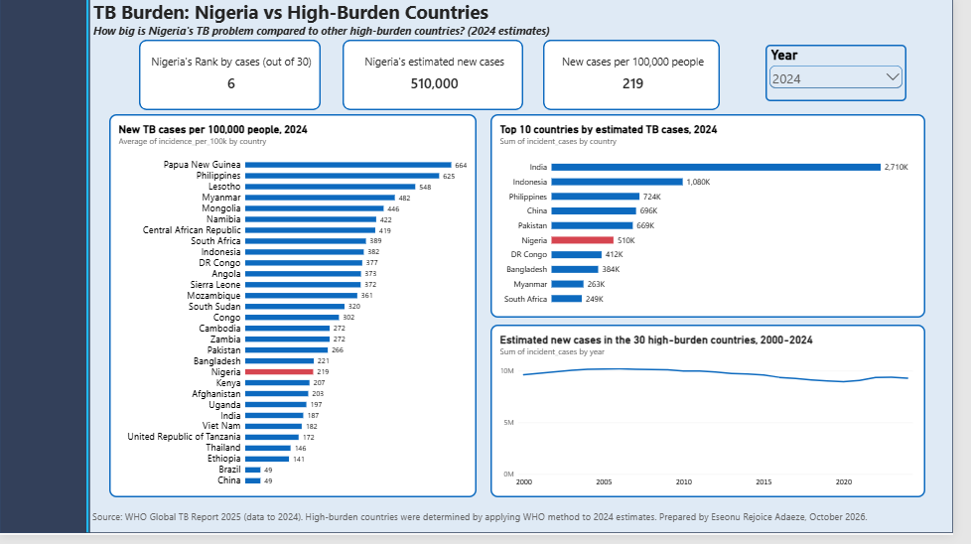
Figure 1: Global Overview of TB burden across selected high-burden countries, 2024.

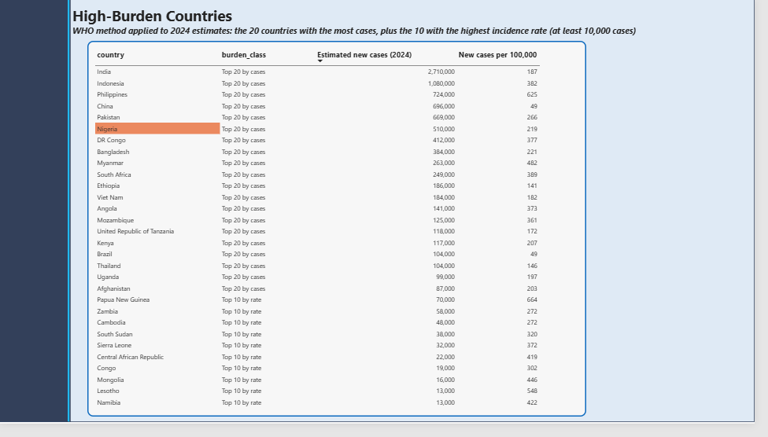Figure 2: Top 30 high-burden countries selected by applying WHO method to 2024 estimates.
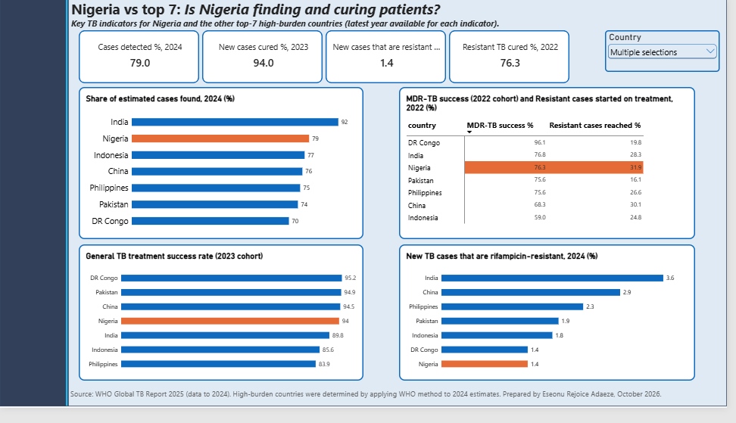
Figure 3: Comparing Nigeria with other top 7 high burden countries on cases detected, treatment success and drug resistance.

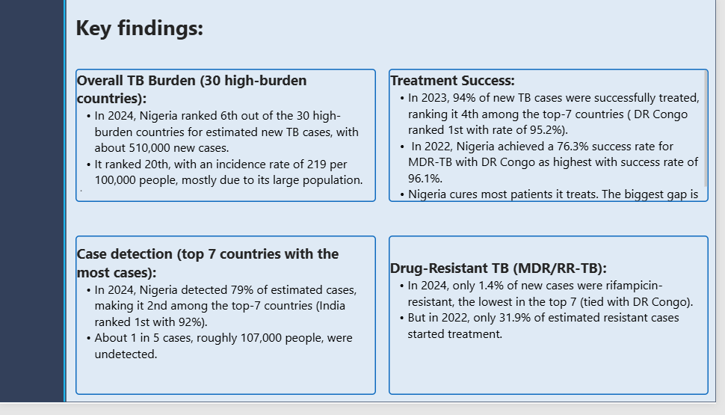
Figure 4: Summary of the key findings.
- Conclusion
Nigeria cures most of the patients it treats (94% success for new cases, and a low share of resistant TB), and compares well with other top high-burden countries on detection and resistance. The biggest gap is finding patients: about 1 in 5 estimated cases is still not detected, and only about one-third of estimated resistant cases started treatment. Treatment success for resistant TB (76.3%) is also well below the success rate of 94% for new cases.
- Recommendations
These follow from the data and are suggestions for further investigation, not policy advice.
- Keep improving case finding, since roughly 107,000 estimated cases are still missed.
- Increase access to testing that detects rifampicin resistance, so that more resistant cases are found and started on treatment.
- Look for ways to raise MDR-TB treatment success, using better-performing countries as a reference.
- Monitor the gap between estimated and reported cases each year.

- Limitations
- DPRK (North Korea) has no estimates in this release, so 25 rows were not loaded.
- 330 rows in the resistance table are blank (countries and territories with no estimates).
- MDR outcomes end at 2022, so 2023 is blank.
- The share of resistant cases reached is an approximate measure (see Methodology).
- WHO figures are estimates from statistical models, and WHO may change them in later reports.
- Nigeria's incidence rate is held constant by the model, so it cannot show a trend.
- The high-burden list follows WHO's method on 2024 data and is not WHO's official list.

Next steps
- Update the dashboard when the 2026 WHO report is released.
- Add TB and HIV co-infection data.
- Compare Nigeria with African peers only.

- References
- World Health Organization. Global Tuberculosis Report 2025: Global Tuberculosis Programme data. Data downloaded on 16th October 2026.
https://www.who.int/teams/global-tuberculosis-programme/data

Appendix
- SQL queries: see tb_burden.sql (GitHub).
- Column names and definitions: see the Data Cleaning Documentation.

